# Modelling Arabidopsis field trials

## Introduction

## Material & Methods

## Results

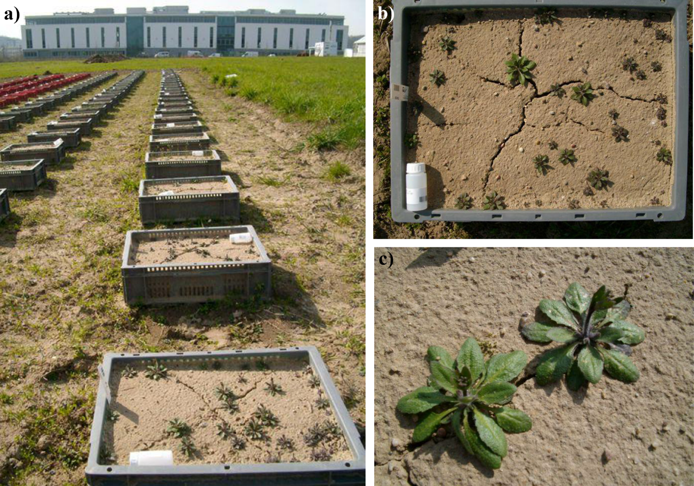

Figure 1 Field trial setup. a) Overview picture of field trial. b) Picture of one box with Arabidopsis thaliana plants (accession Yo-0). c) Close-up view of Arabidopsis thaliana plants (accession Mh-1).

## Discussion

## Supplemental Figures

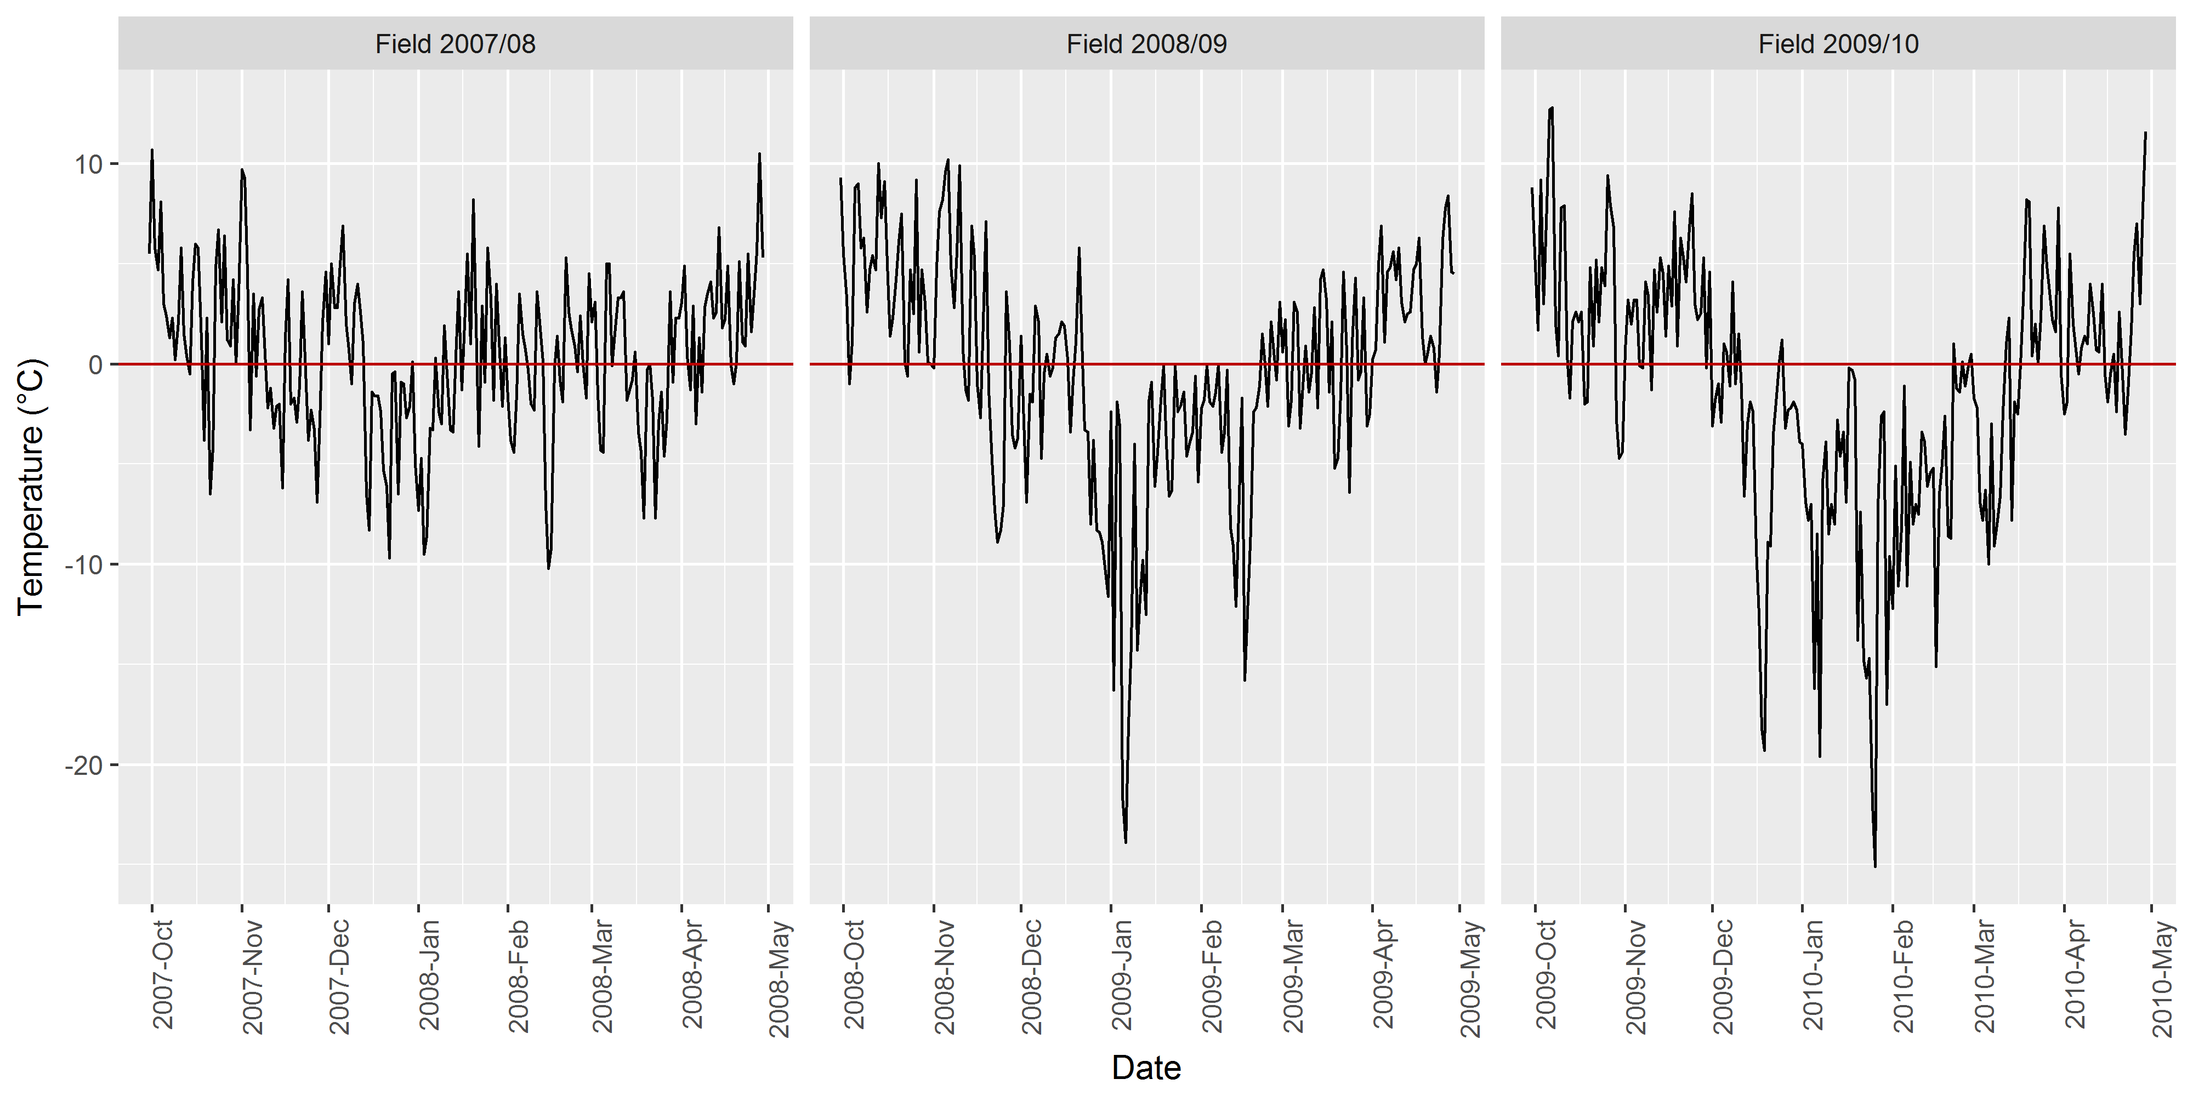

Figure 2: Daily minimum air temperature (in °C) at ground height, measured 5cm above vegetation for three consecutive field trials. Sources: data from weather station in Potsdam, Telegrafenberg http://saekular.pik-potsdam.de/2007_de/

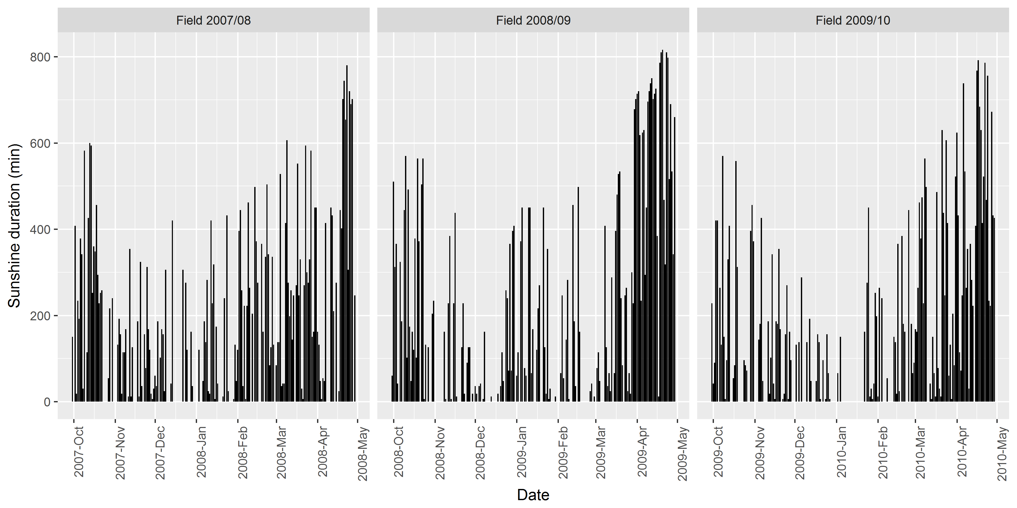

Figure 3: Sunshine duration

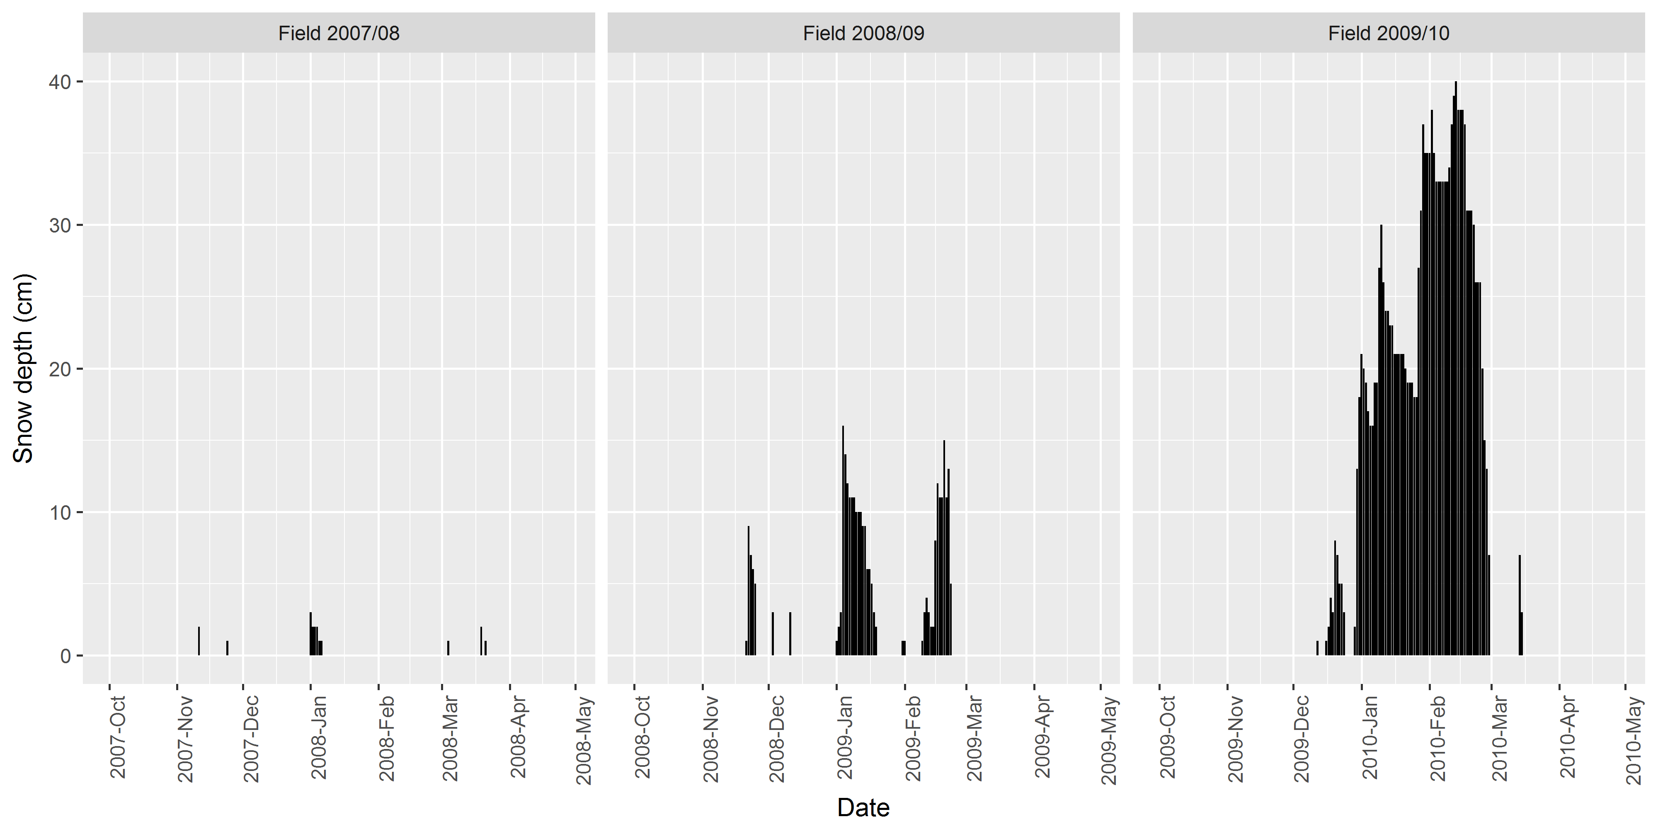

Figure 4: Snow depth

## Supplemental Tables